Project Design Phase-II
Data Flow Diagram & User Stories

Date | JUNE 2026
Team ID
Project Name | Plugging into the Future: An Exploration of Electricity Consumption Patterns
Maximum Marks | 4 Marks

Data Flow Diagrams:
A Data Flow Diagram (DFD) is a traditional visual representation of the information flows within a system. A neat and clear DFD can depict the right amount of the system requirement graphically. It shows how data enters and leaves the system, what changes the information, and where data is stored.
Flow Integration & Dependencies
Sequential Dependencies:
- Data Collection must be completed before Data Preparation
- Data Preparation enables effective Data Visualizations
- Visualizations form the foundation for Dashboard Creation
- Dashboards provide content for Story Development
- Performance Testing runs parallel to all development phases
- Web Integration requires completed dashboards and stories
- Documentation captures the entire development process
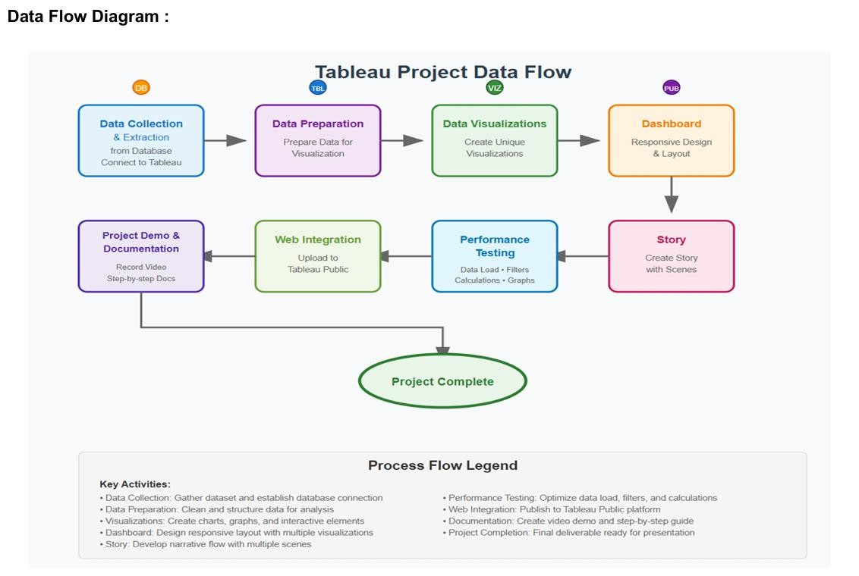

User Stories
Use the below template to list all the user stories for the product.
User Type | Functional  Requirement  (Epic) | User Story  Number | User Story / Task | Acceptance criteria | Priority | Release
Energy Analyst | Dashboard  Performance  Optimization | USN-1 | As an Energy Analyst, I want dashboards to load within 10 seconds even for large electricity consumption datasets, so I can analyze data without delays. | Dashboard loads within 10 seconds; filters respond within 3 seconds. | High | Sprint-1
Energy Manager | Electricity Consumption Overview | USN-2 | As an Energy Manager, I want to view total electricity consumption by region and sector, so I can understand overall energy usage. | Display total consumption, sector-wise percentage, and regional summary. | High | Sprint-1
Data Analyst | Peak Demand Analysis | USN-3 | As an Energy Researcher, I want to identify peak demand periods and seasonal electricity usage patterns, so I can study consumption behavior. | Line chart showing peak demand periods with region filters. | High | Sprint-1
Grid Planner | Regional Consumption Trends | USN-4 | As an Energy Planner, I want to compare electricity consumption across regions over time, so I can support future energy planning. | Time-series chart with monthly/yearly filters. | Medium | Sprint-1
Utility Manager | Sector-wise Consumption Analysis | USN-5 | As a Utility Manager, I want to analyze electricity consumption across residential, commercial, and industrial sectors, so I can improve resource allocation. | Bar chart with sector filters and comparison options. | Medium | Sprint-2
Policy Maker | Region & State Comparison | USN-6 | As a Policy Maker, I want to compare electricity consumption across different states or regions, so I can develop effective energy policies. | Interactive map and comparison chart with region filters. | High | Sprint-2
Energy Forecast Analyst | Electricity Demand Forecasting | USN-7 | As an Energy Forecast Analyst, I want to forecast future electricity demand using historical consumption data, so I can support sustainable energy planning. | Forecast chart showing historical and predicted demand values. | High | Sprint-2
User Type | Functional  Requirement  (Epic) | User Story  Number | User Story / Task | Acceptance criteria | Priority | Release
Public User | Interactive  Dashboard  Access | USN-8 | As a Public User, I want an interactive dashboard that is easy to navigate and understand, so I can explore electricity consumption patterns. | Unified dashboard with filters for region, sector, and time period. | High | Sprint-3

